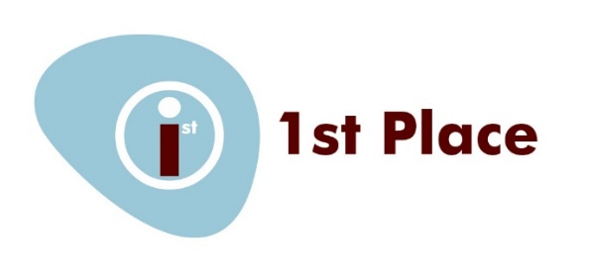

Nursery Privacy Notice
We at 1st Place are the Data Controller for the purposes of the General Data Protection Regulation (GDPR) 2016.
We collect information from you at the point of registration and may also receive information about you from your previous nursery /pre-school. We are committed to ensuring that this personal and sensitive information that we hold about you and your family is protected and kept safe and secure.
We retain this information and use it to:
- Support your child’s teaching and learning
- Monitor and report on your child’s progress
- Provide appropriate pastoral care
- Assess the quality of our provision
- Access funding, when appropriate, for early years provision
- Maintain financial transactions between you and 1st Place
- Provide information to enable the recovery of debt to 1st Place
This information includes contact details, characteristics such as ethnicity, gender, special educational needs and any other relevant medical information.
The law requires us to pass some information to the Local Authority, Southwark Council, and to the Department for Education (DfE).
Your data is held securely and kept strictly confidential. Access is conducted on a strictly need to know basis.
We will not give information about you or your child to anyone outside 1st Place without your consent unless the law requires or allows us to do so.

