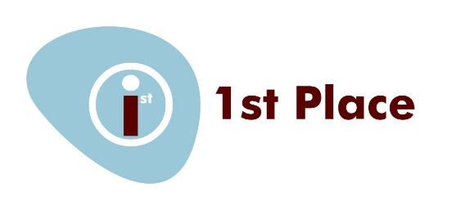

Subject Access Request Form

Please complete this form if you want us to supply you with a copy of any personal data that we hold on you.
We will respond within one month of the date that we:
- Receive your request, or
- Are in receipt of any further information we have requested from you to enable us to comply with your request.
The information that you supply in this form will only be used for the purposes of identifying the personal data you are requesting and responding to your request.
You are not obliged to complete this form to make your request but doing so will make it easier for us to process your request quickly.

SECTION 1: Details of the person requesting information
Full name
Address

Contact telephone
numbers(s)
Email address

SECTION 2: Are you the data subject?
Please tick the appropriate box and follow instructions.
☐ YES: I am the data subject. I enclose proof of my identity (see below). Please go to section 4
☐ NO: I am acting on behalf of the data subject. I have enclosed the data subjects written authority and proof of the data subjects identity and my own (see below) Please go to section 3
To ensure we are releasing data to the right person we require you to provide us with proof of your identity and of your address. Please supply us with a photocopy or scanned image of one of both of the following:
- Proof of Identity - Passport, photo driving license, national identity card, birth certificate
- Proof of address - Utility bill, bank statement, credit card statement (no more than 3 months old), current driving license, current TV License, Local Authority council tax bill, HMRC tax document
If we are not satisfied that you are who you say you are, we reserve the right to refuse to grant your request

SECTION 3: Details of data subject (if different from section 1)
Full name
Address

Contact telephone
numbers(s)
Email address

SECTION 4: What information are you requesting?
Please describe the information you would like from us, giving any relevant details you think may be helpful to enable us to meet your request. i.e. specific dates / emails

Please note that if the information you have requested reveals details directly or indirectly about another person we will need to seek consent from that person before we can allow you to see it.

SECTION 5: Declaration
I confirm that I have read and understood the terms of this access form and certify that the information given is true.
I understand that it is necessary for 1st Place to confirm my / the data subject’s identity and it may be necessary to obtain more information to locate the correct personal data.

Signed:

Date:

Documents which must accompany this application:
- Evidence of identity (see section 2)
- Evidence of data subject’s identity (if different from above)
- Authorisation from the data subject for you to act of their behalf (if applicable)
Please send completed form and documents to:
The Senior Administrator
1st Place Children and Parent’s Centre
12 Chumleigh street
Burgess Park
SE5 0RN
Telephone: 0207 740 8070
Email: sam.tomkins@1stplace.uk.com

If after you receive the information you believe that:
- The information is inaccurate or out of date; or
- We should no longer be holding this information; or
- We are using your information for a purpose of which you were unaware; or
- We have passed inaccurate information about you to someone else.
Then you should notify us immediately.

